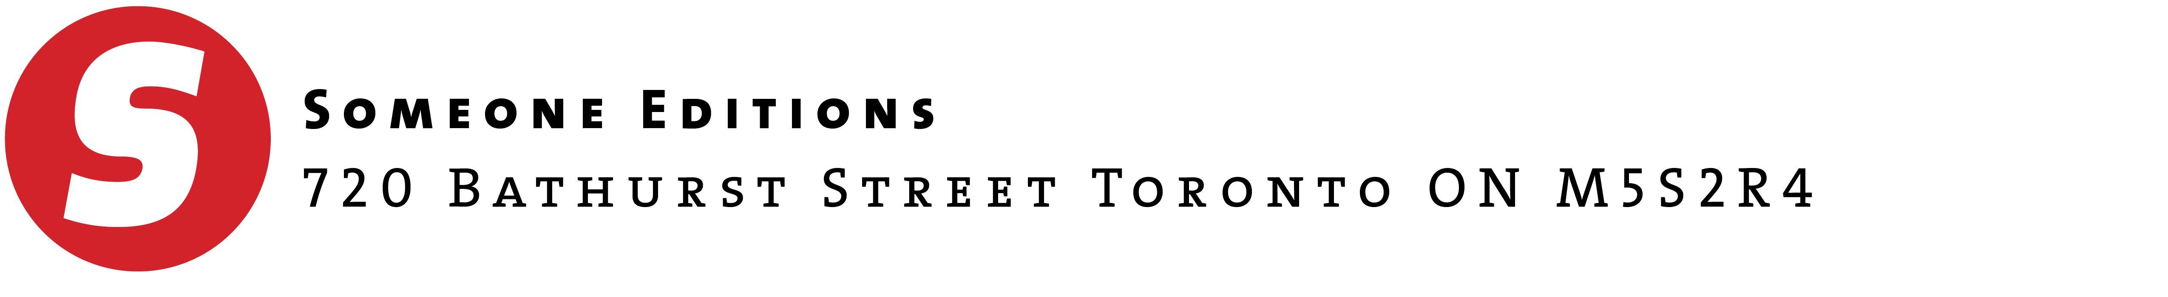

20 May 2018

Call for Participants: Little Letterpress chapbooks
Someone Editions is seeking likeminded artists to collaborate in the production of our Little Letterpress series. If you don’t know us already, Someone Editions is a letterpress atelier dedicated to showcasing artist’s work through the quality craftsmanship of the letterpress medium. Our website with links to our previous projects can be found here.

LITTLE LETTERPRESS CHAPBOOKS
This series consists of deluxe hand sewn chapbooks compiled in sets, each featuring a single poem and original image. Although the chapbooks specifications will vary somewhat as we produce each to enhance the content it is delivering, the chapbook dimensions are standardized at 5.25 x 10”, and all will be crafted on 100% acid free papers, in editions of 52 signed and numbered copies 26 of which will be gathered annually into boxed sets.
ARE YOU A LITTLE LETTERPRESS COLLABORATOR?
We are seeking images that are generated and/or can be experimented with digitally, eventually being letterpress printed.

Specifically we are looking for
- Images that demonstrate a sequence, images created entirely online, and output in solids for photopolymer plates for letterpress (relief) printing
- Artists interested in supplying digital images that can undergo processes to render them in 2-3 separate and distinct analogue inks.

Artists who have already generated images from digital processes, producing solid line art (illustrator outlines) images would be perfect for this project. Also, image-makers who are open to experimentation and want to see their work translated onto the letterpress medium.
As the selected image-maker you would receive a number of the chapbooks for free and additional chapbooks at cost (if you wanted additional copies), as well as a commission on the additional copies that are sold. The image-maker, author, designer and publisher would split the commission of sold copies at 25% each.
THE TIME IS NOW!
We are looking for submissions for our summer and fall 2018 projects. We will remain open for submissions through September 2018. If your interest is peaked don’t hesitate!

Please send your application to deborahsomeone@gmail.com

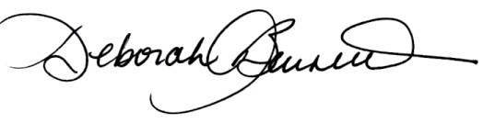

Deborah Barnett
Creative Director, publisher

